# Vysoká škola báňská - Technická univerzita Ostrava

# Počítačové siete

Projekt návrhu siete

Vypracovali:

Emil Bednár BED0092

Martin Hrobárik HRO0061

**Zadanie:**

**Firma:** daiha

**Číslo topologie:** D

**Čísla VLAN:** VLAN A=14, VLAN B=90

**Počty stanic na segmentech:** VLAN A=131, VLAN B=39, Segment S1=32

**Rozsah veřejných adres:** 162.128.192.0/18

**Rozsah privátních adres:** 172.25.14.0/24

**Rozsah IPv6 adres:** 2001:672d:be82:3000::/52

**Zvláštní segmenty:** **NAT:** VLAN A, **DNS:** Segment S1 (PC3), **DHCP:** VLAN B, **T:** Segment S1,

**N:** VLAN B

**NAT pool:** 12

**Směrovací protokol:** RIP

**Zadaná topológia:**

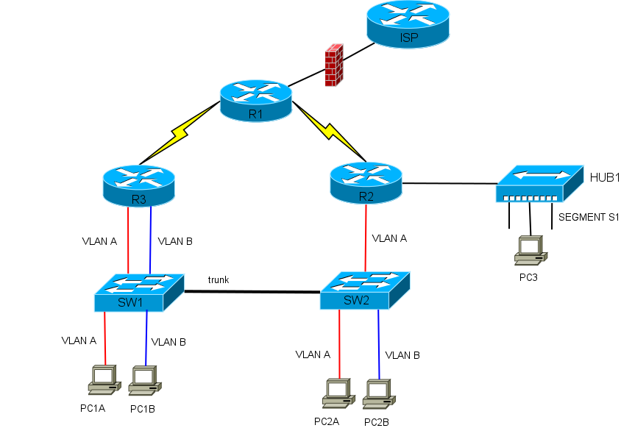

**Ekvivalentná topológia podľa L3:**

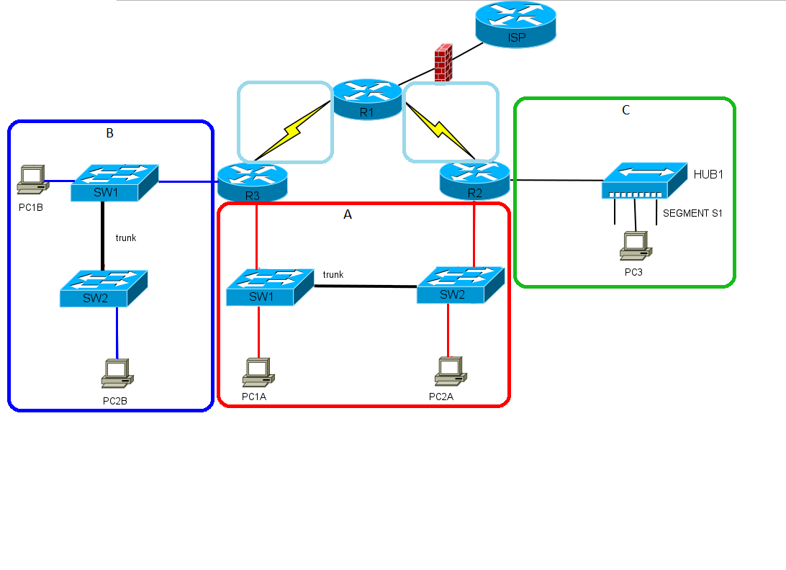

**DNS server:** 162.128.192.126

**Adresný plán IPv4:**

|  |  |  |  |  |  |
| --- | --- | --- | --- | --- | --- |
| **Segment:** | **Adresa podsiete:** | **Maska podsiete:** | **Rozsah adries:** | **Broadcast:** | **Gateway:** |
| A - priv. | 172.25.14.0 | 255.255.255.0 | .1 - .254 | .255 | R2: .1, R3: .2 |
| B | 162.128.192.0 | 255.255.255.192 | .1 - .62 | .63 | R3: .1 |
| C | 162.128.192.64 | 255.255.255.192 | .65 - .126 | .127 | R2: .65 |
| D - NAT pool | 162.128.192.128 | 255.255.255.240 | .129 - .142 | .143 | - |
| R1 - R2 | 162.128.192.144 | 255.255.255.252 | .145 - .146 | .147 | R1: .145 R2: .146 |
| R1 - R3 | 162.128.192.148 | 255.255.255.252 | .149 - .150 | .151 | R1: .149 R3: .150 |
| R1 - ISP | 10.0.0.0 | 255.255.255.252 | .1 - .2 | .3 | R1: .2 |

**Adresný plán IPv6:**

|  |  |  |
| --- | --- | --- |
| **Segment:** | **Adresa + Maska podsiete:** | **Gateway:** |
| A - priv. | 2001:672d:be82:3001::/64 | R2: .1, R3: .2 |
| B | 2001:672d:be82:3002::/64 | R3: .1 |
| C | 2001:672d:be82:3003::/64 | R2: .1 |
| D - NAT pool | 2001:672d:be82:3004::/64 | - |
| R1 - R2 | 2001:672d:be82:3005::/64 | R1: .1 R2: .2 |
| R1 - R3 | 2001:672d:be82:3006::/64 | R1: .1 R3: .2 |
| R1 - ISP | 2001:672d:be82:3007::/64 | R1: |